CONG TY CO PHAN XAY Dl)NG COTECCONS *COTECCONS CONSTRUCT/ON JOINT STOCJ( COMPANY*

### CQNG HOA :xA H◊I CHU NGHIA VI(tT NAM

**Dqc l�p** - Tv do - **H�nh phtlC**

## THE SOCIALIST REPUBLIC OF VIETNAM

### Independence - Freedom - Happiness

*TP. H6 Ch£ Minh, ngay A9 thang 10 nam 2023* Ho Chi Minh city, OC1t>bd J_f *1 2023*

## CONG BO THONG TIN BAT THUONG

#### *EXTRAORDINARY INFORMATION DISCLOSURE*

**Kinh giri/ *To:*** *-* **Uy Ban Chtrng Khoan nha mr6'c/ *State Securities Commission*** *of* ***Vietnam***

- **S& Giao djch Chtrng khoan Vi?t Nam/ S& Giao djch Chtrng khoan Ha Nqi/ S& Giao djch Chtrng khoan thanh ph6 H6 Chi Minh/ *Vietnam Exchange/ Hanoi Stock Exclumge/ Hocfliminh Stock Exchange***

1. Ten t6 *chfrc/Name of organization:* Cong ty C6 ph�n Xay D1,rng Coteccons Ma chtrng khoan/Ma thanh vien/ *Stock code/ Broker code:* CTD

##### Dia *chi/Address:* 236/6 Di�n Bien Phu, P.17, Q. Binh Th?-nh, TP. HCM Di�n tho?-i lien *h�/Tel.:* (84) (28) 35142255 - Fax: (84) (28) 35142277 E-mail: [bodsecretary@coteccons.vn](mailto:bodsecretary@coteccons.vn)

1. N(>i dung thong tin cong *b6/Contents of disclosure:*

##### Nghi quySt H(>i d6ng quan tri v6 vi�c phe duy�t chu trno·ng mua l?-i 100% v6n g6p cua m(>t Cong ty ho?,t d(>ng trong IInh v1,rc xay di.-rng.

*Board of Directors' Resolution approving the proposal to acquire 100% equity of a Company Operates* in construction business.

1. Thong tin nay da duqc cong b6 tren trang thong tin di�n tfr cua cong ty vao ngay *di /1..01..2�.l&t?-i* duong d�n: *https://coteccons. vn/investor-relations-vn/ /This information was published on the company's*

*website on OctD b..e,,* 1...J-' *ffv* , *as in the link https://coteccons. vn/investor-relations-vnl*

Chung toi xin cam kSt cac thong tin cong b6 tren day la dung sµ· th�t va hoan toan chiu trach nhi�m trn6-c phap lu�t v� n(>i dung cac thong tin da cong b6/ *We hereby certify that the information provided is true and correct and we bear the full responsibility to the law.*

Tlli lifu dhth lceml ***Attached doc11111e11ts:*** TY Nghi quyBt HDQT

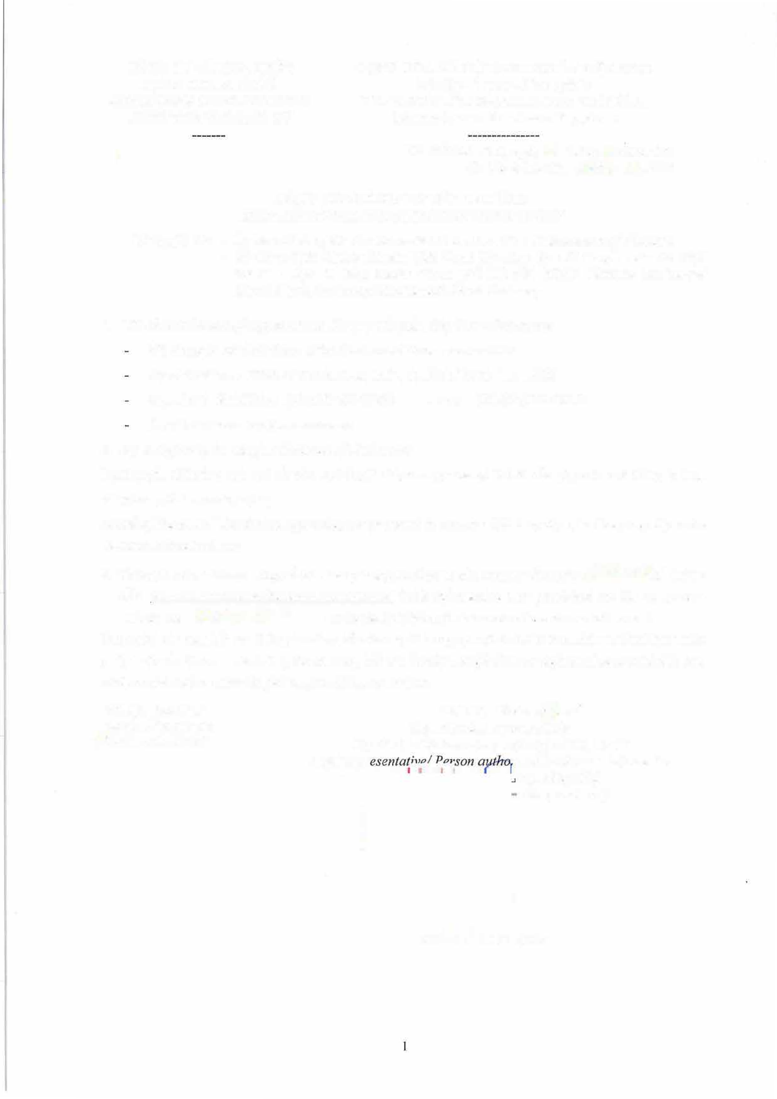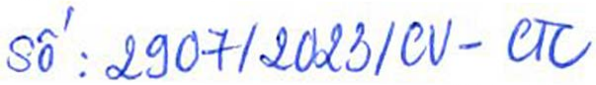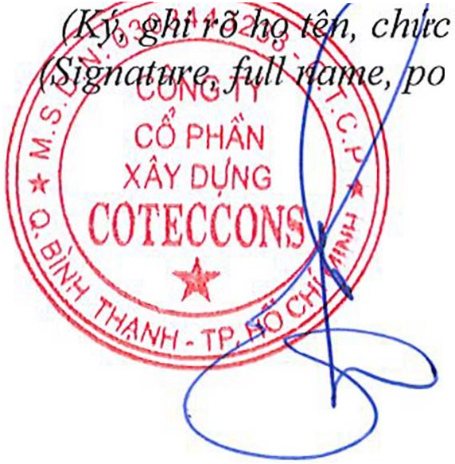

### D�i di?n t6 cht"rc�

#### *Organization representative*

##### Nguo·i d?,i di�n theo phap luWNguo·i UQ CBTT

*Legal repr �="""-'-- ·ized to disclose informatioi*

*v�,. tl6ng ddu)* sition, and seal)

**BOLAT DUISENOV**

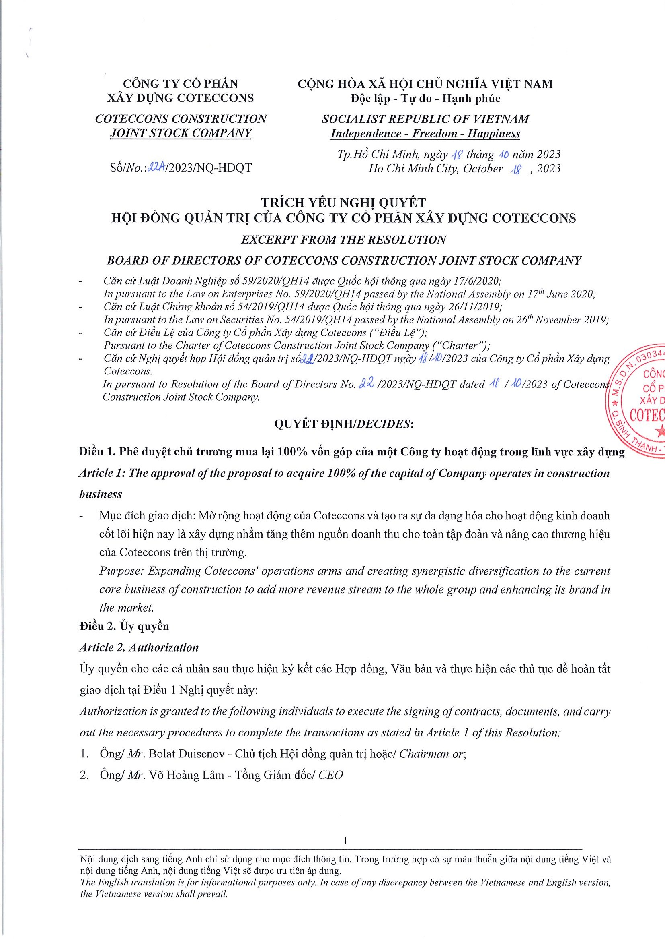

# PHẦN XÂY DỰNG

Digitally signed by CÔNG TY CỔ PHẦN XÂY DỰNG COTECCONS

DN: C=VN, S=THÀNH PHỐ HỒ CHÍ MINH, CN=CÔNG TY CỔ PHẦN XÂY DỰNG COTECCONS, OID.0.9.2342.19200300.100.1.1=MST: 0303443233



CÔNG TY CỔ

Reason: I am the author of this document

COTECCONS

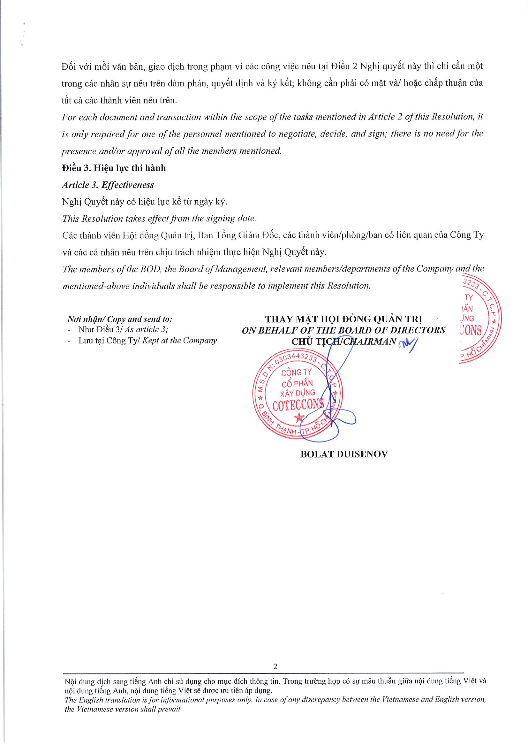Location: your signing location here Date: 2023.10.18 16:00:23+07'00'

Foxit Reader Version: 10.1.0